Mapping language, arts, culture and community – continuity and change

Dr. Douglas Chalmers,
Lecturer in Economics,
Cultural Business Division Glasgow Caledonian University

The ‘uneasy relationship between culture and economic development’ (Keane 1993) has served for some time as an area of tension within the language development community (Chalmers and Danson 2004), and continues to provide an area of fruitful research.
Within Scotland, and in relation to Scottish Gaelic, this work has a growing body of literature attached to it (Pedersen 1993; Sproull 1996; Sproull and Chalmers 1998; Chalmers 2003; Chalmers and Danson 2004). It has also attracted a body of literature more critical of how such a relationship may be carried out in practice. (MacCaluim and McLeod 2001; McLeod 2002; Lang 2004)

In 1998, following a survey of the Gaelic speaking areas of Scotland within the ‘Gaelic Economy’, Sproull and Chalmers published an analysis of demand for Gaelic related goods and services within the Eilean Siar (Western Isles), and Skye and Lochalsh, which sought for the first time, to map the buying patterns of consumers, and production patterns of ‘suppliers’ of Gaelic related art and cultural products. Within this study some broad questions were raised as to the impact of Gaelic artistic and cultural production on a broad range of variables that affected the economic health of the community, some of which were measurable as ‘hard’ data, such as jobs created, skills provided, and some of which were more subjective (though intuitively extremely important) such as ‘the level of confidence’ in local communities, the ‘level of attachment of young people’ to their local communities etc, the levels of in and out migration etc.

This work was continued by Chalmers as part of his PhD on the Economic Impact of Gaelic Arts and Culture (Chalmers 2003) where broadly positive conclusions were drawn as to the complementary interaction of well considered and sculpted economic development (particularly through artistic and cultural production) on the potential regeneration of the Gaelic language. This was not to argue that economic development could be seen as a substitute for a well crafted language policy, but that if designed correctly it could be one element to help underpin such a strategy by helping provide a vibrant enterprising, cultural and social community, where the ‘diversity dividend’ of a healthy minority language would be acknowledged and appreciated.

Ten years on from the original data collection (which took place in 1996), a ‘re-run’ of much of the original Sproull and Chalmers study is taking place in order to allow comparison by the authors of the situation in the post Gaelic Language Bill environment and on the cusp of the inauguration of a new Gaelic Digital TV channel.

In addition to revisiting many of the questions, concepts and issues of the first study, a deepening of our understanding of several concepts is being sought by the inclusion of new questions regarding the relationship between language and culture itself (treated as synonymous in previous work, and by most current policy practitioners in their day to day work)

Diagram 1 below outlines the general area of study being undertaken:
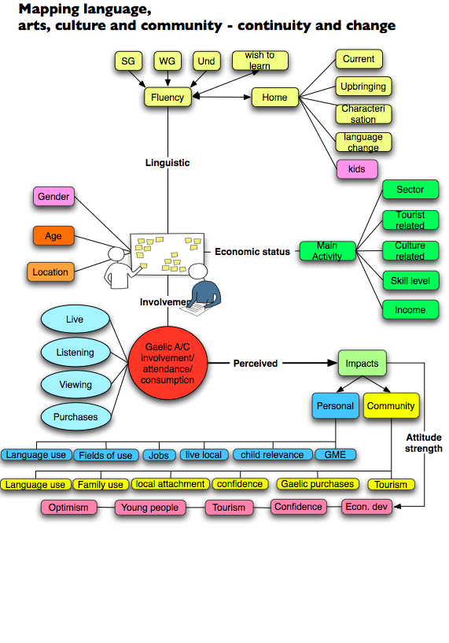

Within the study, data is sought on a whole range of characteristics held by those who consume (buy/ use/ attend/ take part in), Gaelic artistic and cultural activities. This data relates to issues such as location, gender, age, a whole range of indications on minority language fluency, changes in language use, employment data such as employment sector, skill and income level, whether their employment is tourist or culture related etc.

Data is also collected on the level of involvement in a whole range of Gaelic related cultural and artistic activity – such as attendance at different categories of Gaelic related music events, theatre, exhibitions, storytelling, poetry reading etc. This is supplemented by data outlining viewing patterns and listening patterns to Gaelic TV and Radio, how this pattern has changed over the last five years, and what are perceived as the main constraints to increasing this.
Finally questions are also asked in relation to internet use through the medium of Gaelic and the extent of involvement with Gaelic language sections in local newspapers.
With this invaluably rich data, comparisons can be made to the patterns of a decade ago, allowing longitudinal research into changing trends in consumption – something which in itself will be interesting given demographic changes within the Gaelic speaking communities, and also the period of relative ‘marking time’ which has been experienced over much of the last ten years, while communities waited for much heralded change in policies to actually result in subsequent action.

Perhaps more important than this however, is a continuation of the investigation of the impact of consumption on the economic and societal indicators mentioned above in terms of confidence, attachment, vibrancy of communities, and on levels of use of the language in families and communities. The data, most of which is now in, promises to be very interesting in the suggestions it will offer on such possible linkages and long term impact. Unfortunately since a complete analysis has not yet been made, it would not be appropriate to summarise it here yet. The general conclusions however will be released in early November and further work will continue in the period following this.

A final point that needs flagged up in terms of breaking now ground is the issue of the relationship between language and culture. A new aspect of the current study is a whole range of new questions aiming to illuminate perceived notions of the relationship between language and culture.
To enable this respondents were asked to state whether they believed that either or both of the two main Gaelic speaking areas in Scotland – Eilean Siar and Skye and Lochalsh ‘have a high degree of distinctiveness’ from the rest of Scotland and if so what the sources of the distinctiveness might be.
Respondents were then given a whole range of possible distinctive attributes ranging from the ‘Gaelic language’ to Gaelic culture, Gaelic artistic activities, Gaelic ‘world view’, distinctive economic activities (such as crofting), the landscape, religious difference, place names etc, which they were asked to rank. They were finally asked to rank a series of statements on the relationship between the language and the culture, whether culture can exist without language, or to what extent culture is seen to be linked to the language etc. Early indications are that views on this will serve to deepen the existing debate in this area.

Overall we hope that the rich data set collected in this project will serve to progress the debate regarding cultural, linguistic and economic regeneration, and serve as an invaluable source of information for the Gaelic speaking community and all those interested in the potential that linguistic and cultural diversity may offer.

Bibliography.

Chalmers, D. (2003). The Economic Impact of Gaelic Arts and Culture. Division of Economics and Enterprise. Glasgow, Glasgow Caledonian University.
Chalmers, D. and M. Danson (2004). Language and Economic Development - Complementary or Antagonistic? Rannsachadh na Gàidhlig 2004, Edinburgh.
Chalmers, D. and M. Danson (2004). Sustainable Development: Building Social Capital in Gaelic language Communities. Scottish Economists Conference, Perth.
Keane, M. J. (1993). "Rural and Local Development in Ireland: Exploring the theory-practice interface." Regional Studies 27: 173-178.
Lang, A. (2004). Cruthachadh agus cleadadh: ceistean air planadh cànain agus na h-ealain Ghàidhlig. Rannsachadh na Gàidhlig, Edinburgh, Department of Celtic Studies, Edinburgh University.
MacCaluim, A. and W. McLeod (2001). Revitalising Gaelic? A critical analysis of the report of the taskforce on public funding of Gaelic (the MacPherson report). Edinburgh, Roinn na Ceiltis agus Eòlas na h-Alba, Oilthigh Dhùn Eideann.
McLeod, W. (2002). "Language Planning as Regional Development? The Growth of the Gaelic Economy." Scottish Affairs(38): 51 - 72.
Pedersen, R. N. (1993). The dynamics of Gaelic development, Highlands and Islands Enterprise.
Sproull, A. (1996). "Regional Economic Development and Minority Language Use - the case of Gaelic Scotland." International Journal of the Sociology of Language 121: 93 - 119.
Sproull, A. and D. Chalmers (1998). The Demand for Gaelic Artistic and Cultural Products and Services: Patterns and Impacts. Glasgow, Glasgow Caledonian University: 80.

